ALU Functional Simulation: [Update these in report] (Remove old screenshots)

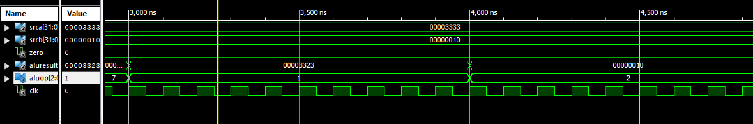
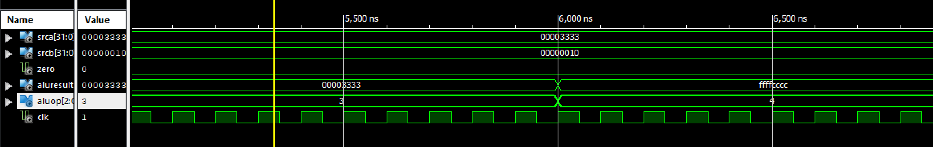
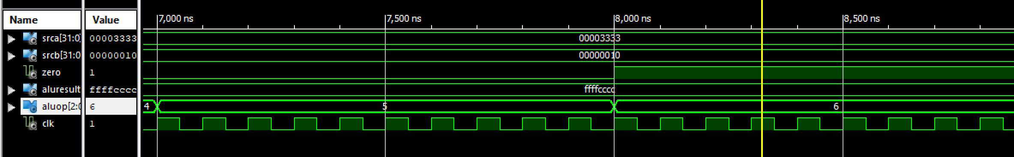

ALU Timing Simulation:
